Communication Channels Formula
Project managers use a communications channel formula to calculate the number of potential communication channels in a project. This assists in developing the Project Communication Management Plan. If anyone is interested in taking the PMP exam, you most certainly need to know how to calculate the Channels Formula.
Basics
The larger the project gets the more stakeholders need to be involved. With a large number of stakeholders, the project manager will need to allocate resources and choose the correct methods of communication for each given stakeholder. This is where the Communication Channels Formula can help quantify the complexity of project communications.
For example, let’s say you are a project manager for a small, personal project and you only have a total of three stakeholders, you and two others. There are 3 people in your communications channel and only three potential communication channels:
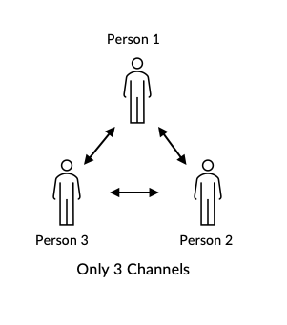
In this case communications channels are simplified.
But what if we have 6 different stakeholders? The communication channel becomes much more complex. All of these stakeholders can communicate with you and with one another. With an increased number of stakeholders, we also increase the total number of possible channels of communication.
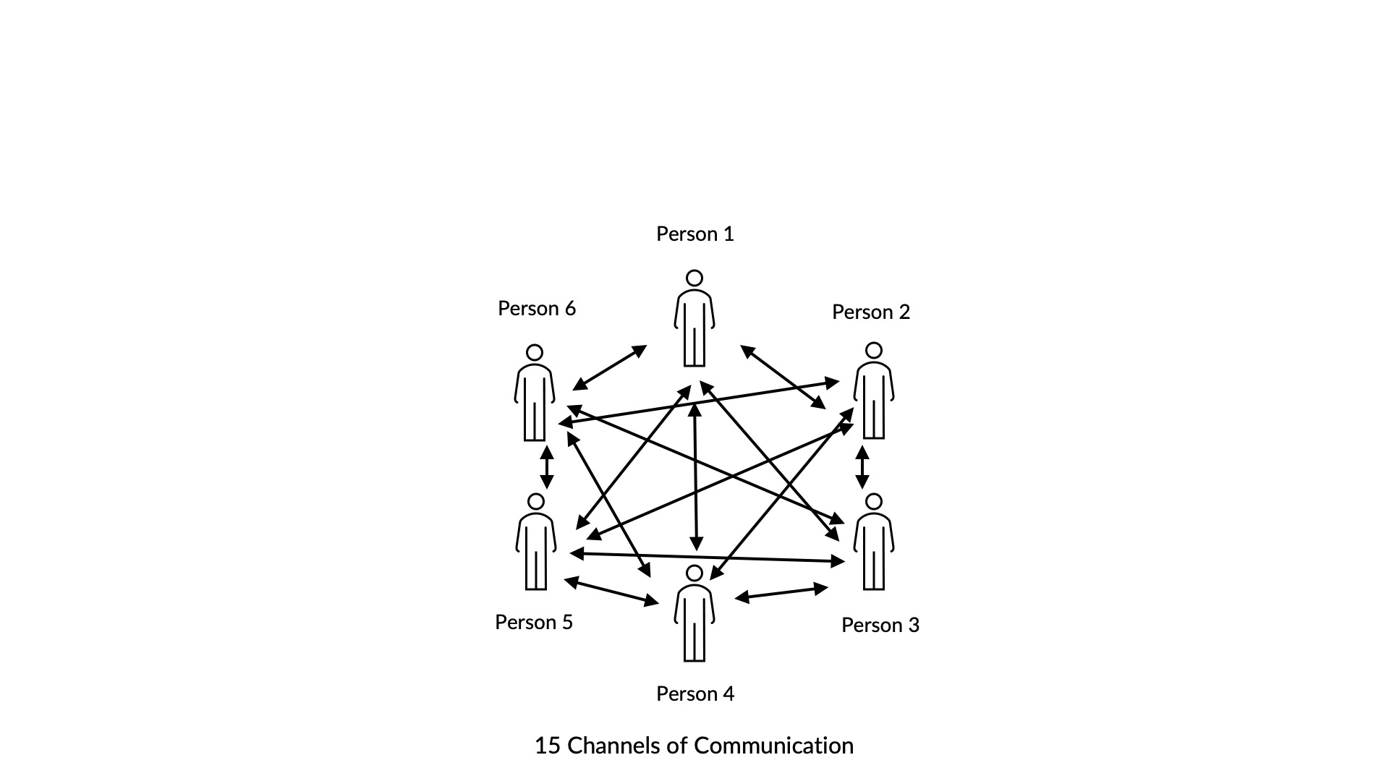
Determining the Total Number of Communication Channels
The formula for figuring out the number of channels is
Channels = N (N - 1) / 2
N = total number of people or stakeholders
Small Project:
In the case of the small project we can easily calculate the number of channels
Channels = 3 (3 - 1) / 2
3 (2) / 2
6 / 2 = 3 total communication channels
Larger Project:
Channels = 6 (6 - 1) / 2
6 (5) / 2
30 / 2 = 15 total communication channels

